**GITHUB – PART 2**

**Creating a file in Remote repository**

Provide the file name and add a description to that file. To commit the changes in the repository, click ‘Commit New File’

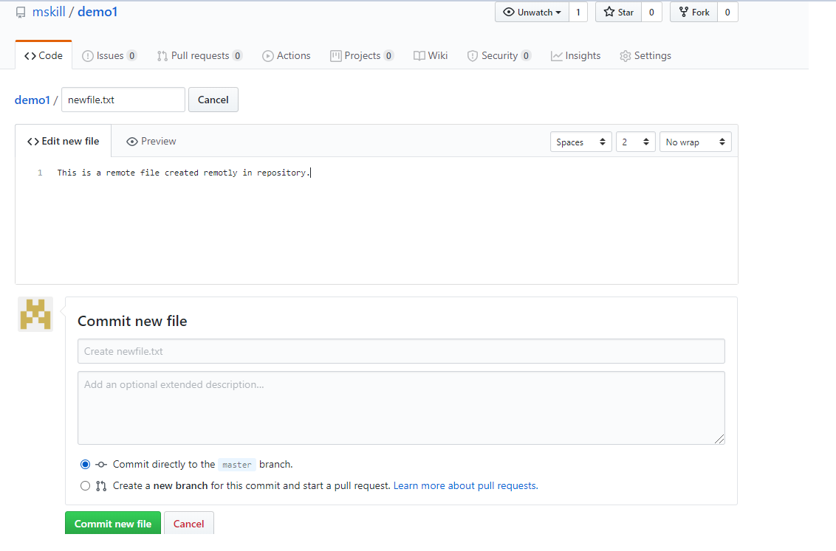

Adding a file remotely will not be there in the local directory. Check the files using dir

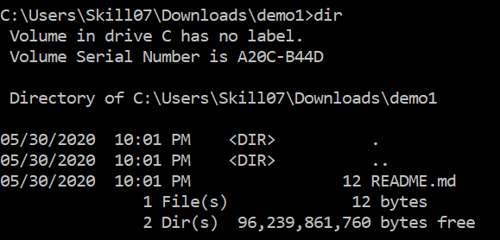

As per the screenshot above, there is 1 file in the repository.

To pull the file that is added in remote repository to local repository, we use PULL command

git pull

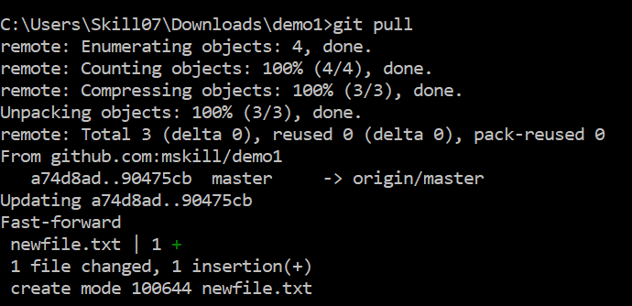

After pull, if I check the local repository using dir, there are 2 files as shown:

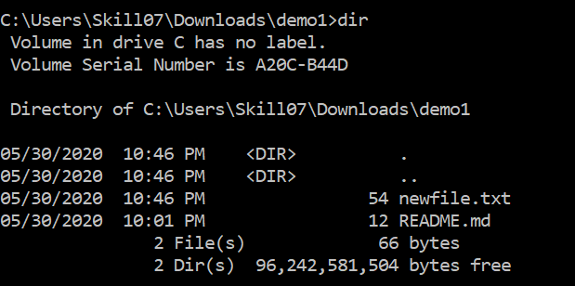

To add a branch in master branch

git branch branchname

Switch the branch

git checkout branchname

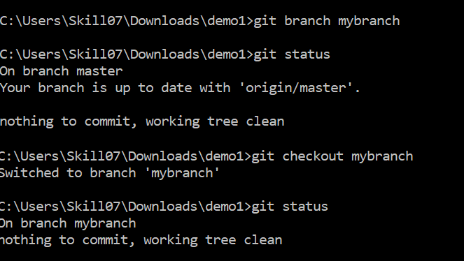

Adding a file in branch

echo "#content">> filename.txt

Then add the file and push the file. To create the branch remotely we have to use

git push --set-upstream origin branchname

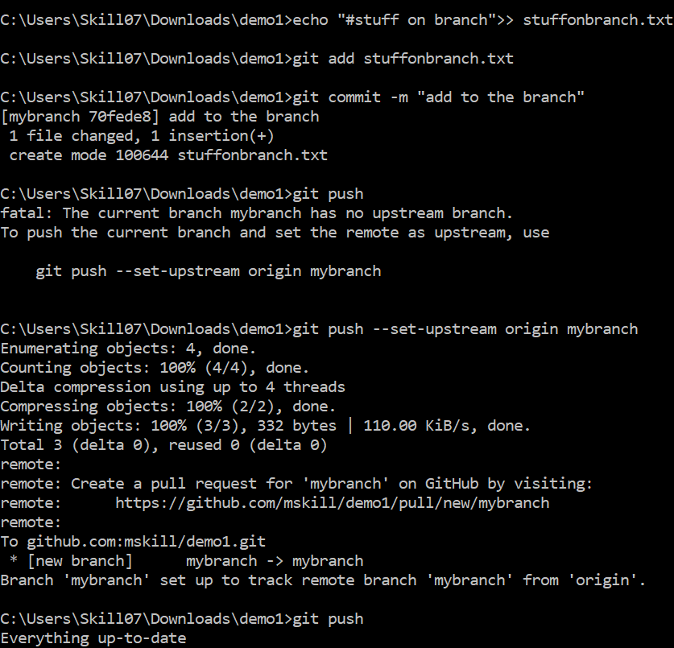

Switch the branch again to the master using

git checkout master

Merge command to merge the branches

git merge mybranch

As the merge command is used the new create branch will be merged to the master branch and the file will be inserted to it. Previously, we have 2 file in the master, now there are 3 files. Make sure to push the files using git push

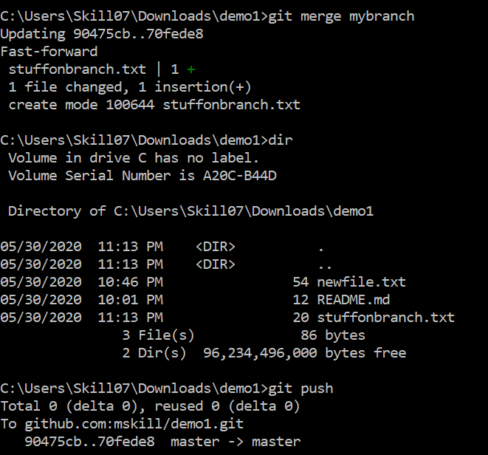

Now, the file which is in the branch, is now in the master branch

